1. Print the first name, last name, patronus of all characters who have a patronus and it is known

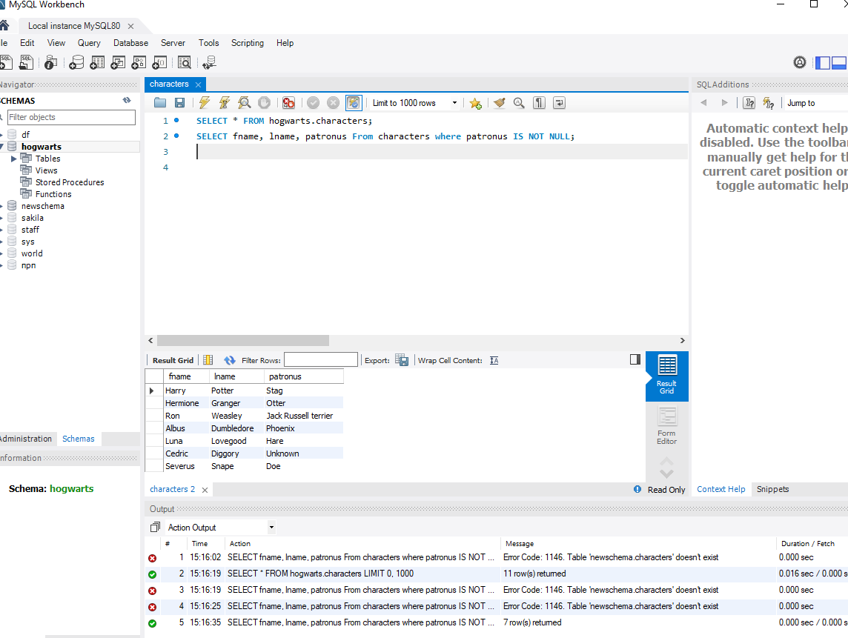

1. Print the last name of characters whose last letter is 'e'

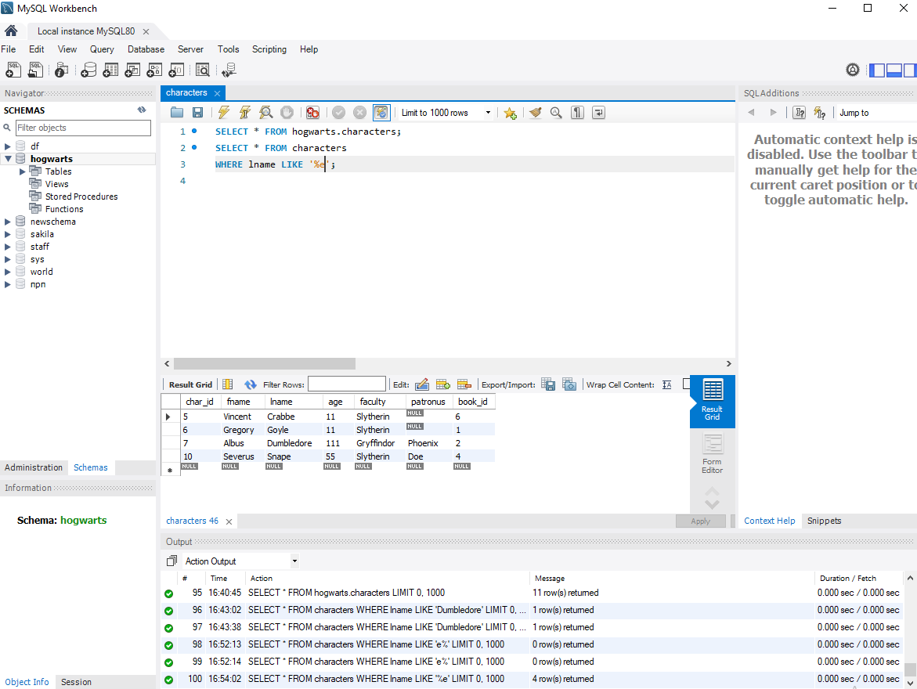

1. Calculate the total age of all characters and display it on the screen

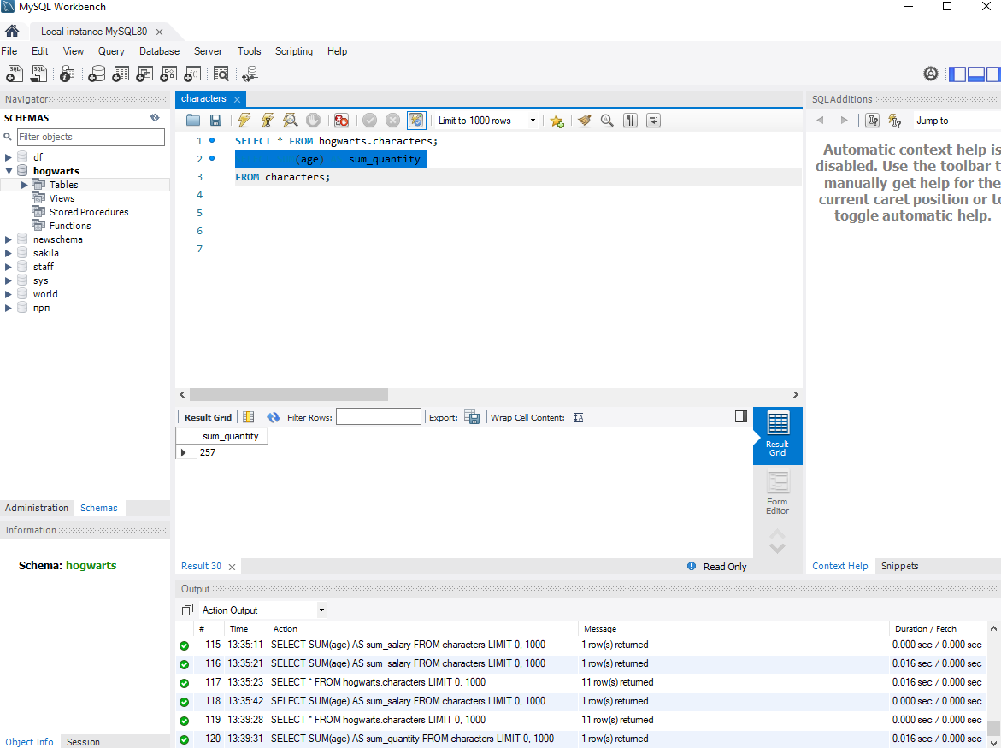

1. Print the first name, last name and age of the characters in descending order of their age

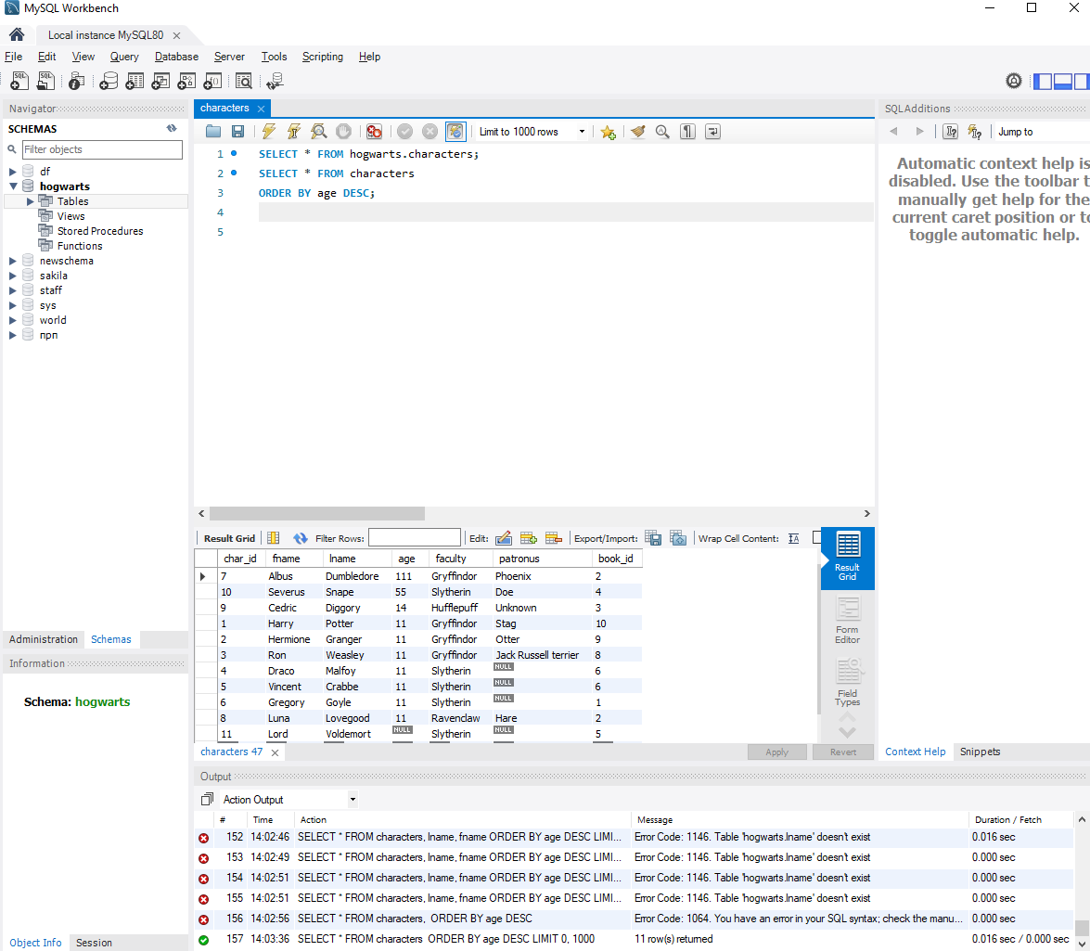

1. Print the character's name and age, whose latter is in the range from 50 to 100 years

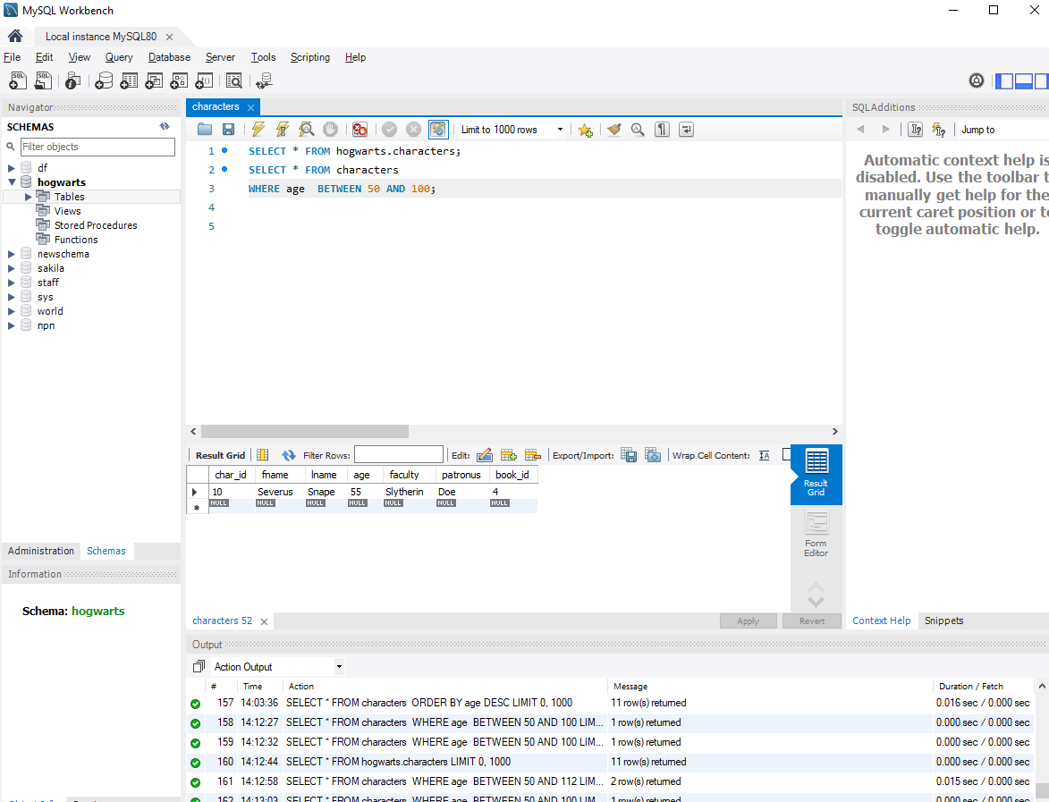

1. Print the ages of all characters so that none of them have the same age

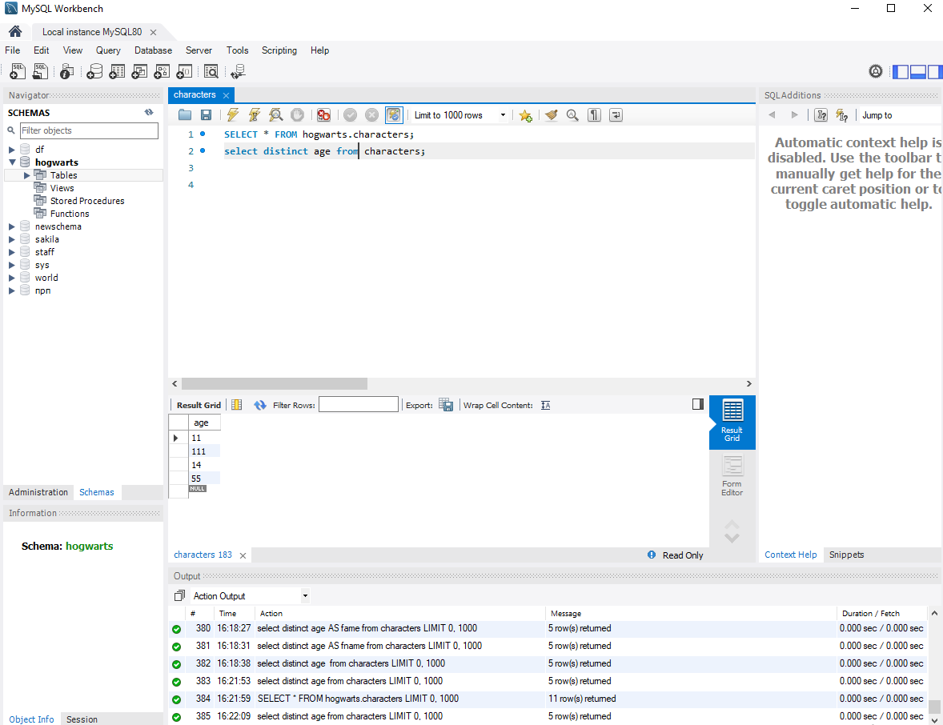

1. Print all information about characters whose faculty = Gryffindor and whose age is over 30 years old

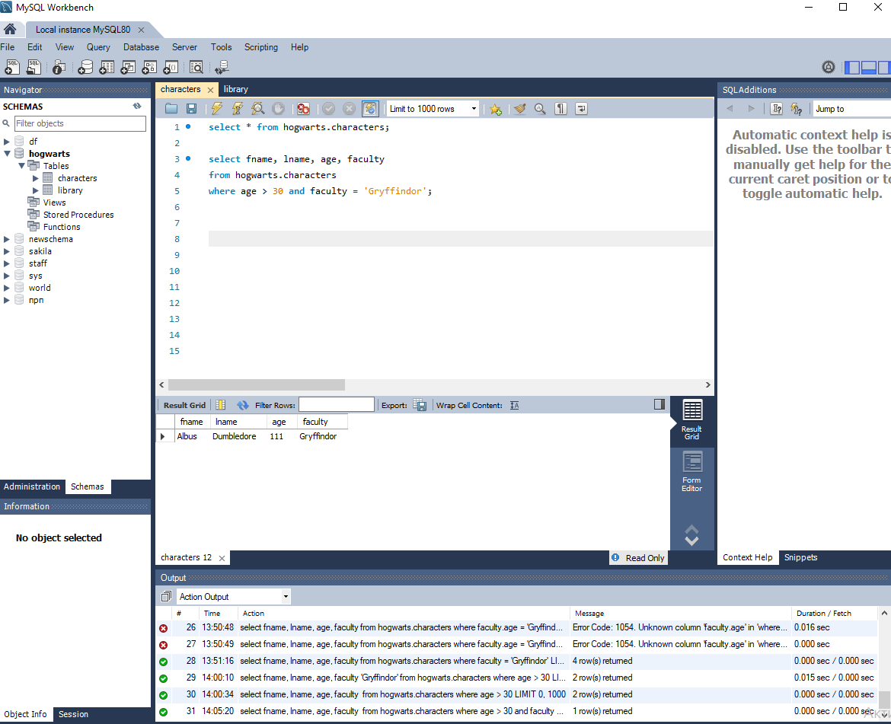

1. Print the names of the first three faculties from the table, so that faculties are not repeated

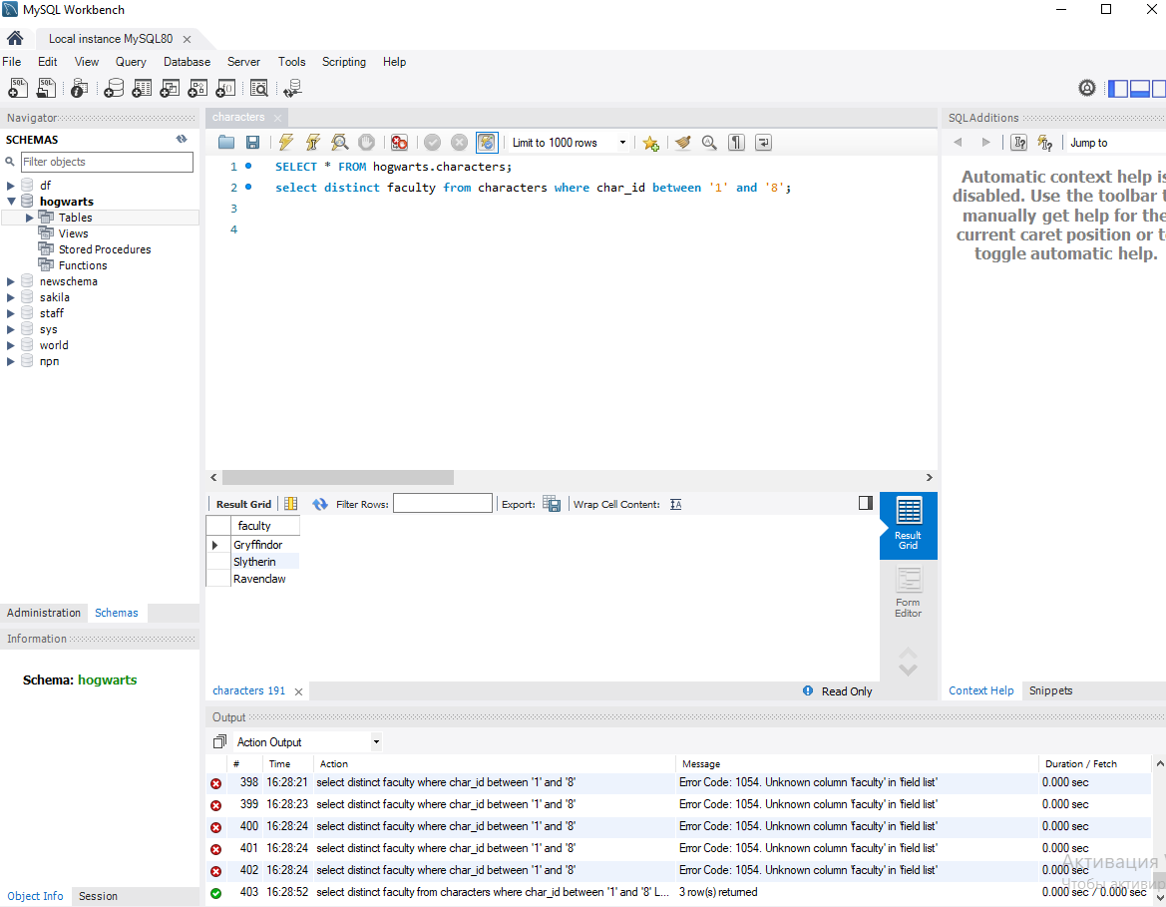

1. Print the names of all characters whose name starts with 'H' and consists of 5 letters, or whose name begins with 'L'

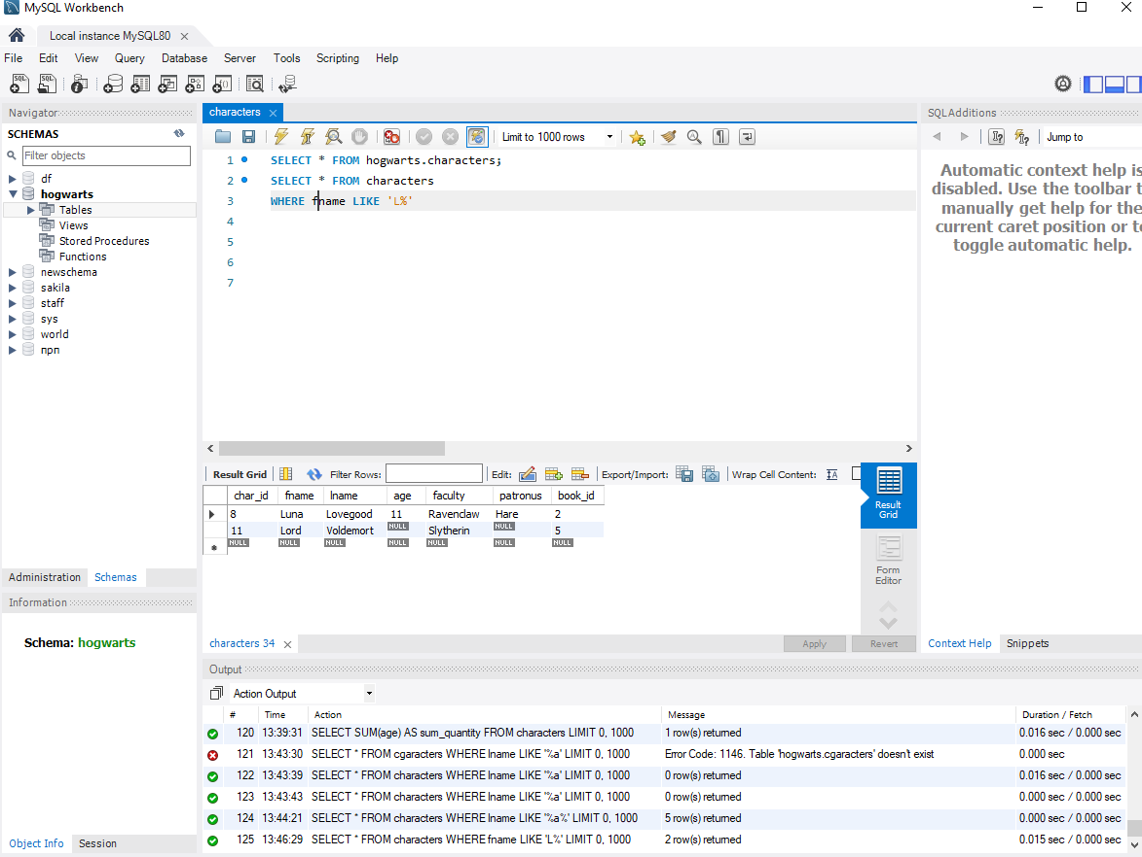

1. Calculate the average age of all characters

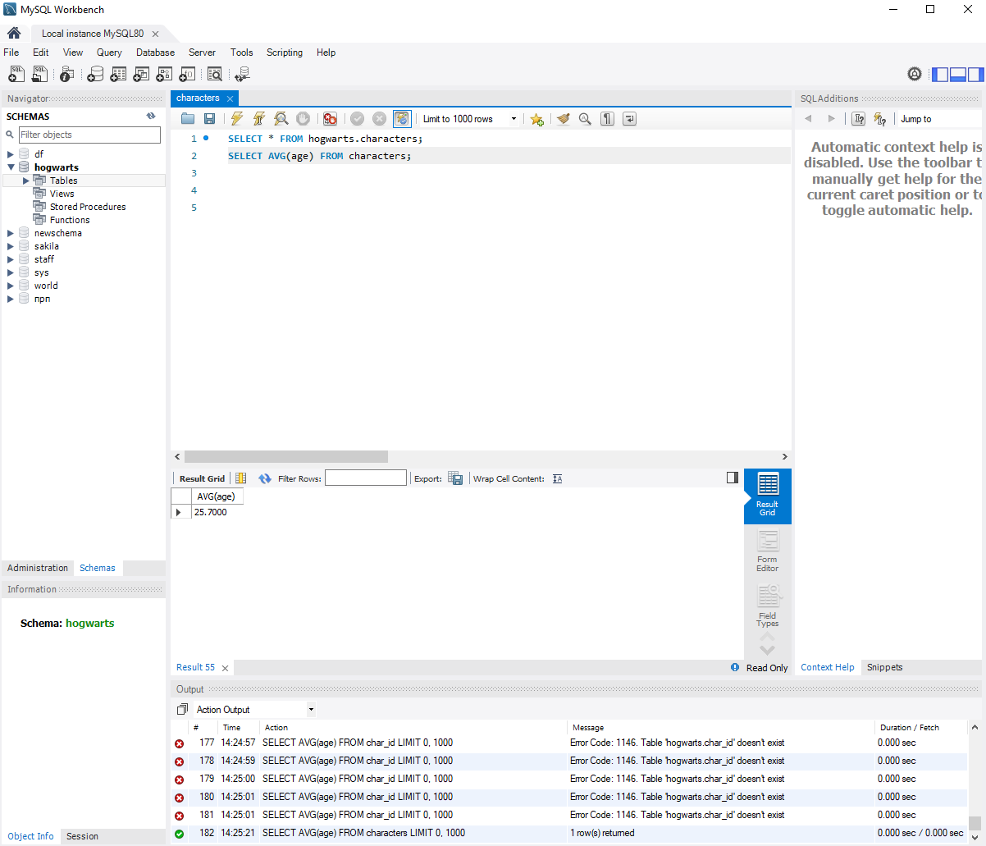

1. Remove character with ID = 11

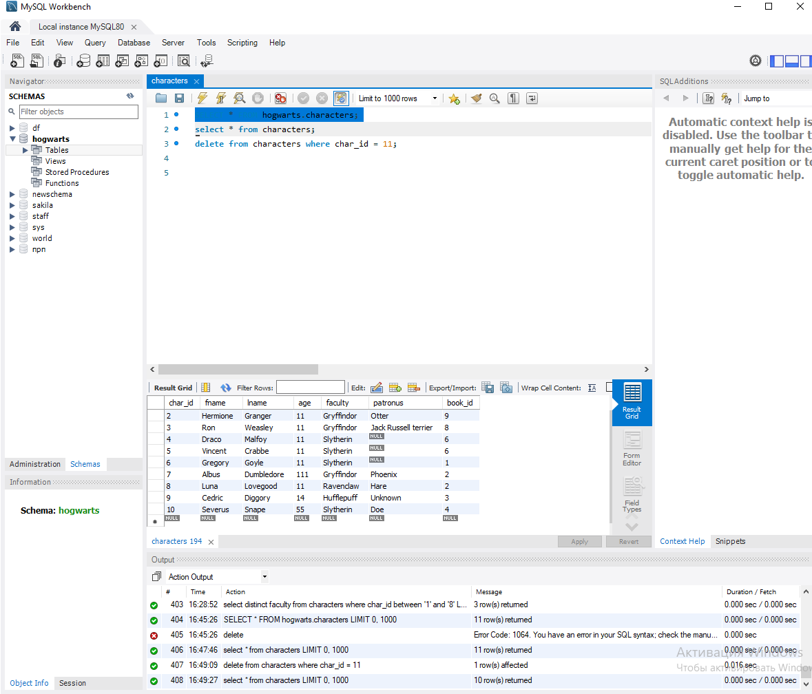

1. Print the last name of all characters that contain the letter 'a'

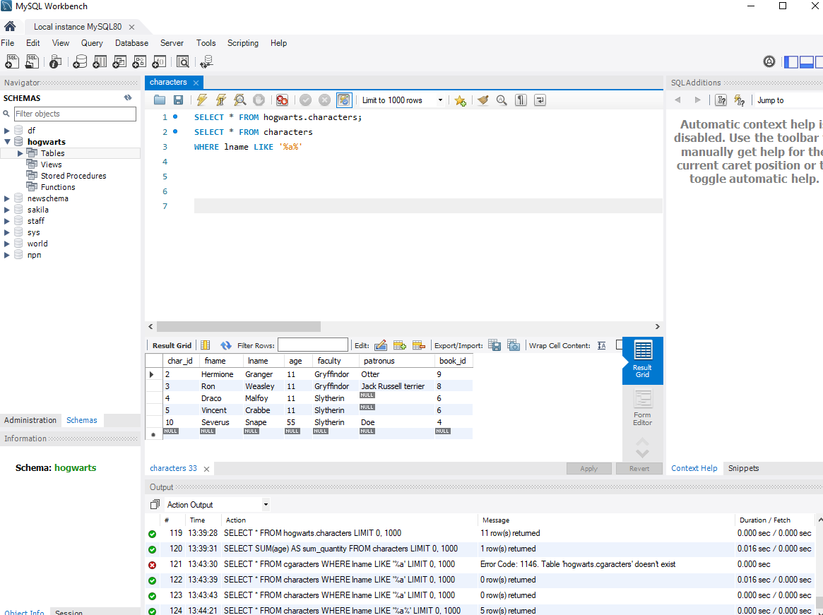

1. Use an alias to temporarily replace the fname column with Half-Blood Prince for the actual Half-Blood Prince

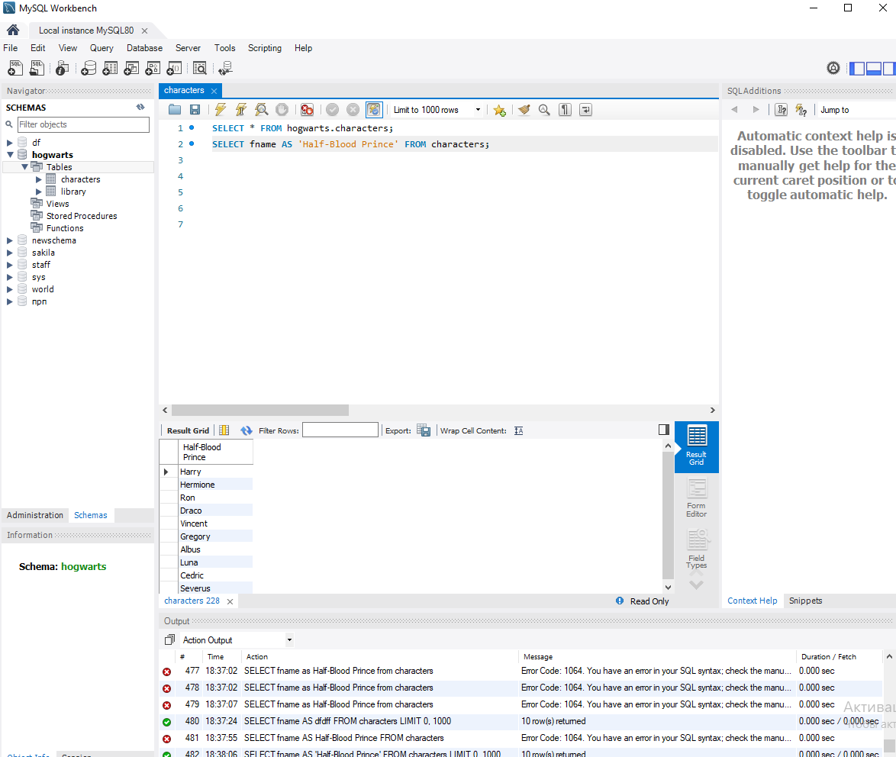

1. Print the id and names of all patronuses in alphabetical order, provided that they exist or are known

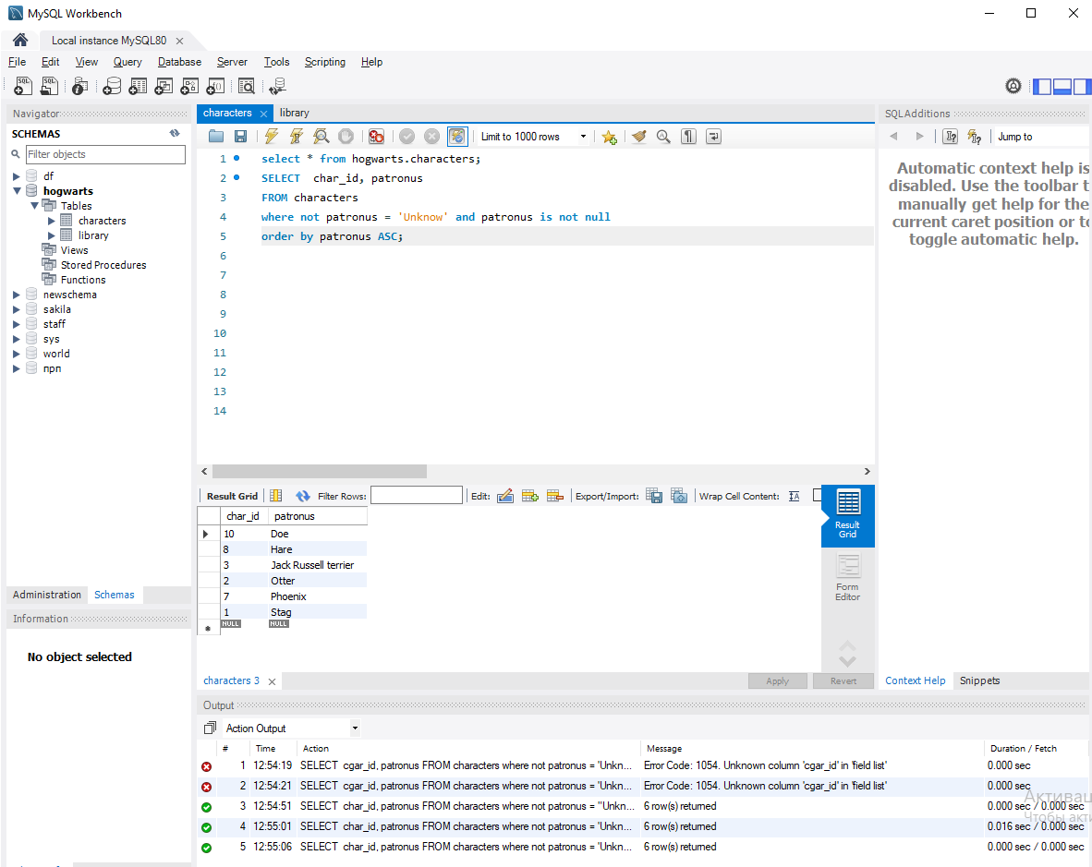

1. Using the IN operator, print the first and last names of those characters whose last name is Crabbe, Granger or Diggory

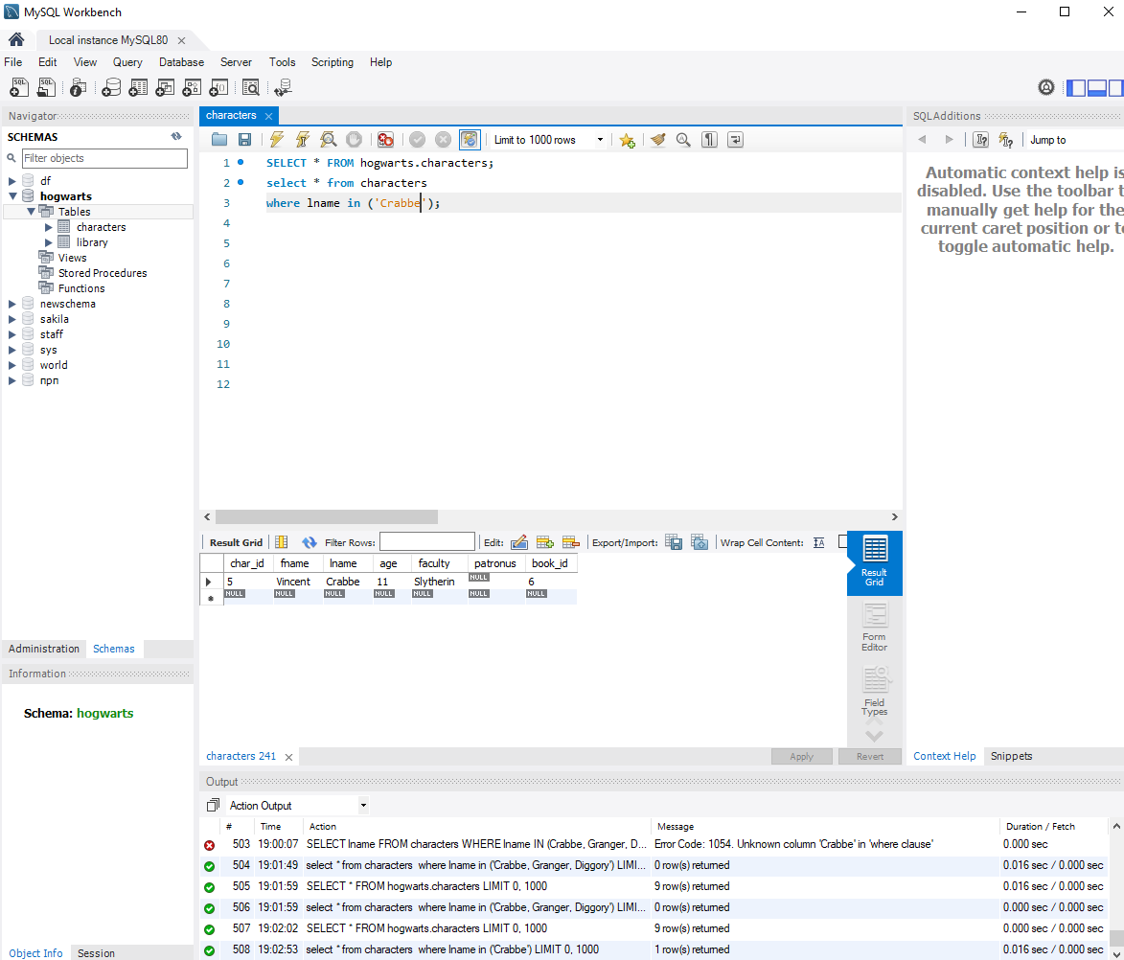

1. Print the minimum age of the character

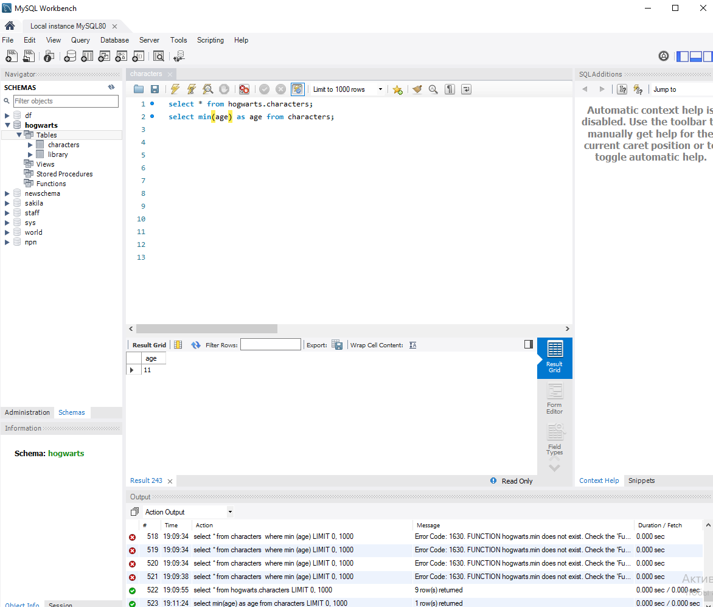

1. Using the UNION operator, select names from the characters table and book titles from the library table

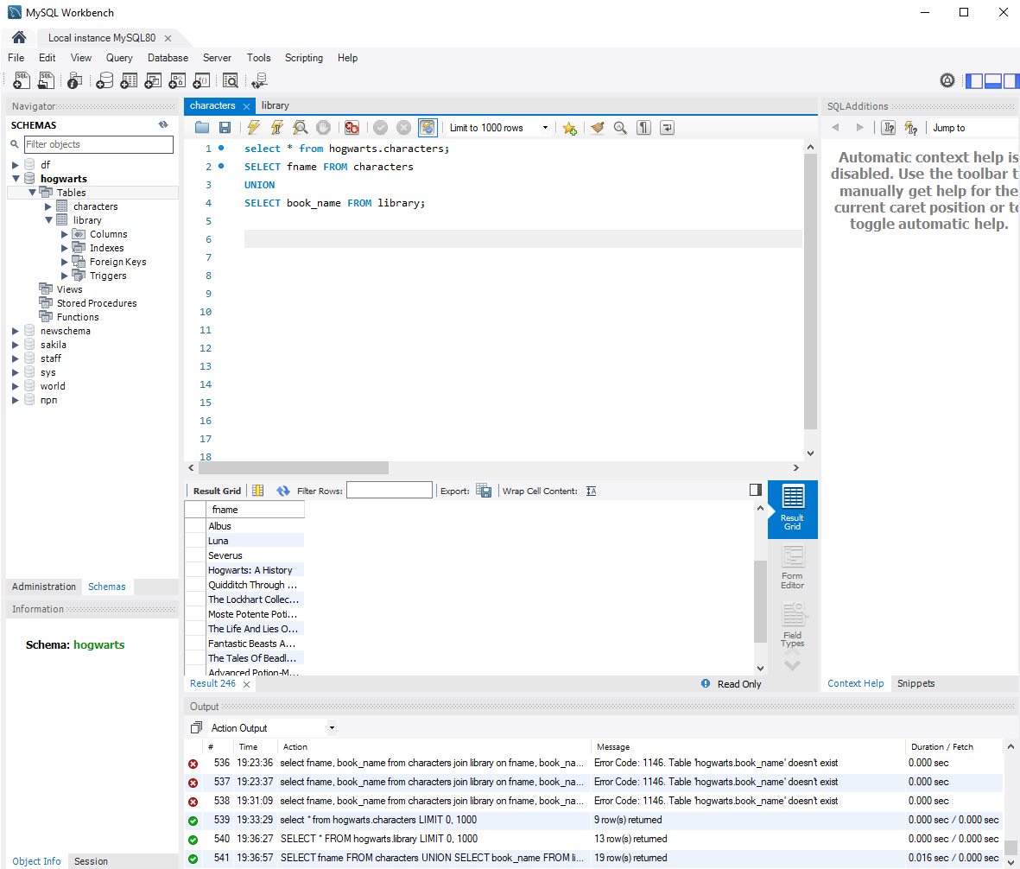

1. Using the HAVING operator, count the number of characters in each department, leaving only those departments where the number of students is greater than 1

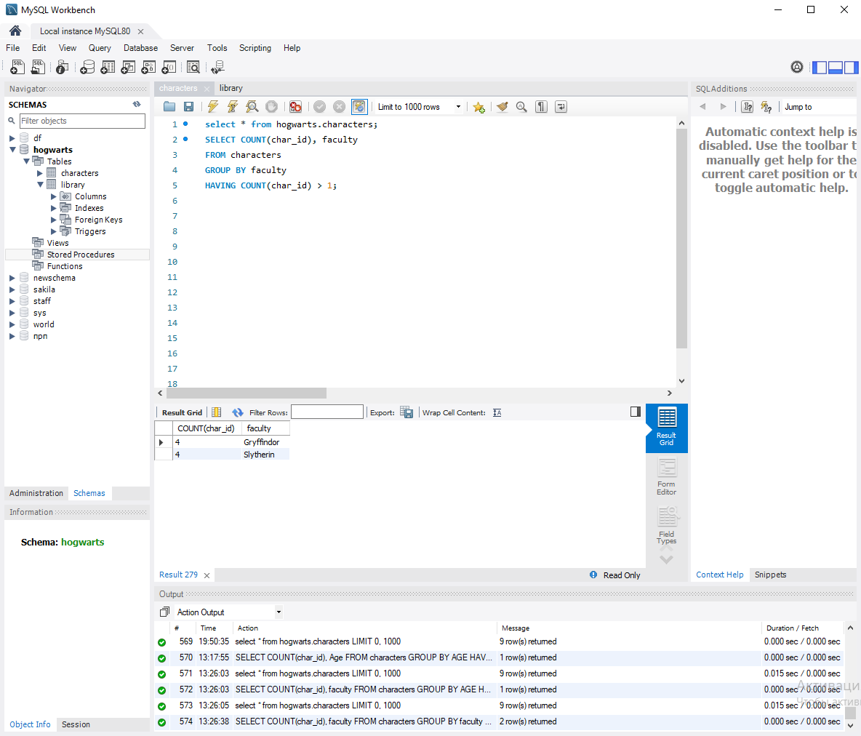

Using the CASE statement, describe the following logic:

Print the character's first and last name, as well as the following text message:

If the faculty is Gryffindor, then the console should display Godric

If the faculty is Slytherin, then the console should display Salazar

If the faculty is Ravenclaw, then the console should display Rowena

If the faculty is Hufflepuff, then the console should display Helga

If there is other information, then Muggle is displayed

Please use the pseudonym Founders to post

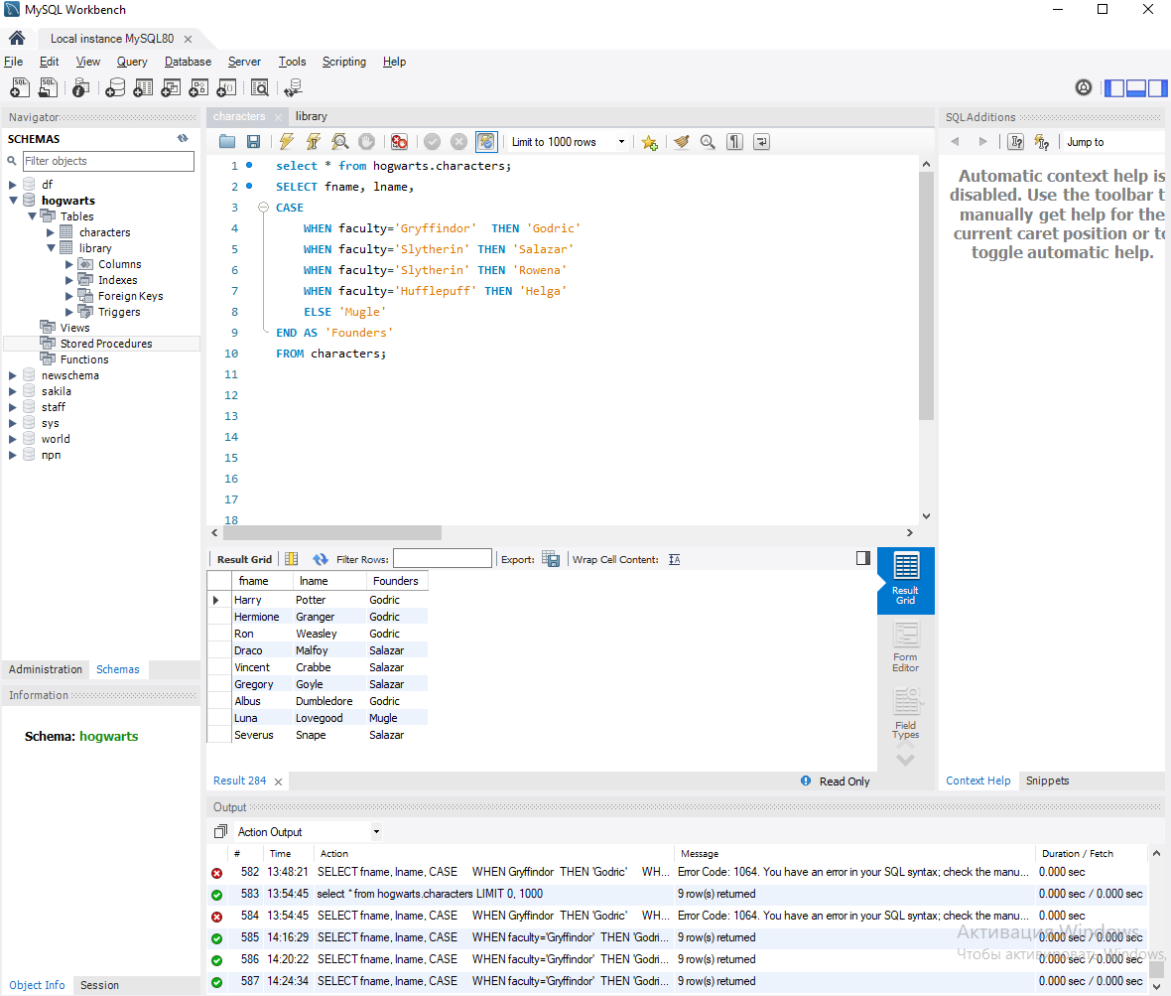

1. Using a regular expression, find the last names of characters that do not start with the letters H, L or S and print them

